Adjective Poems

- An adjective is a poem of 6 lines which accumulates a list of adjectives.
- Creating an adjective poem is good practice for identifying and using adjectives, as well as introducing to word order and adjectival agreement.
- There is a suggested pattern:
Line 1: Noun
Line 2: Same noun + is/are + adjective
Line 3: Same noun + is/are + adjective 1, adjective 2
Line 4: Is/are + adjective 1, adjective 2, adjective 3
Line 5: Adjective 1, adjective 2, adjective 3 , adjective 4
Line 6: New (related) noun

Eg:
Languages
Languages are essential
Languages are essential and creative
Are essential, creative and powerful
Essential, creative, powerful, fun
Communication

Suggested Lesson Plan
1. Draw on previous knowledge of adjectives by presenting a noun and asking students to provide suitable adjectives that relate to it. Discuss position of adjectives and adjectival agreement, if necessary.
2. Tell students that they are going to create a poem comprising mostly adjectives
3. Students create an adjective poem in groups, then alone (perhaps for homework)
and then perform it to the class and create calligrams for display.
Note: this lesson can be used with a topic being studied or for descriptions of
people, places, hobbies, interests, etc.

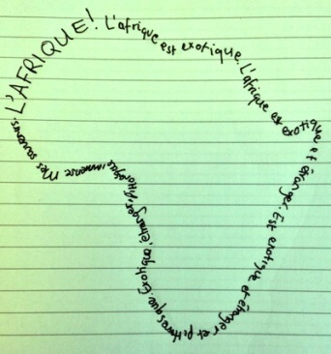

L’Afrique
L’Afrique est exotique
L’Afrique est exotique et étrangère
Est exotique, étrangère et pittoresque
Exotique, étrangère, pittoresque et immense
Mes souvenirs

